Publishing Indexes
Schindler CRD Applications

Exported on 2025-08-19 06:15:16

Table of Contents

1 Overview 3
2 Index Creation 4
3 References 5
3.1 PTC Articles 5
3.2 PTC Cases 5

Overview
- Publishing index needs to be created to improve publishing performance

Index Creation
- Connect to database
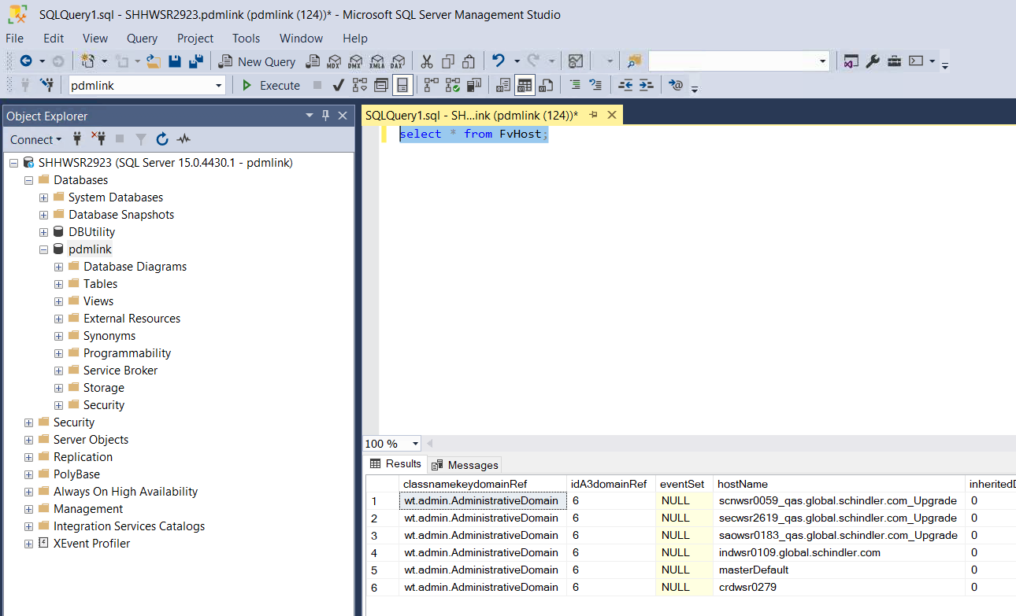
- Run below queries
create index ClashToClashReportL$CS277373_E on ClashToClashReportLink(idA3E6) ON INDX;create index ClashToClashReportL$CS277373_F on ClashToClashReportLink(idA3F6) ON INDX;create index ClashToClashReportL$CS277373_A on ClashToClashReportLink(idA3A6) ON INDX;create index ClashToClashReportL$CS277373_B on ClashToClashReportLink(idA3B6) ON INDX;
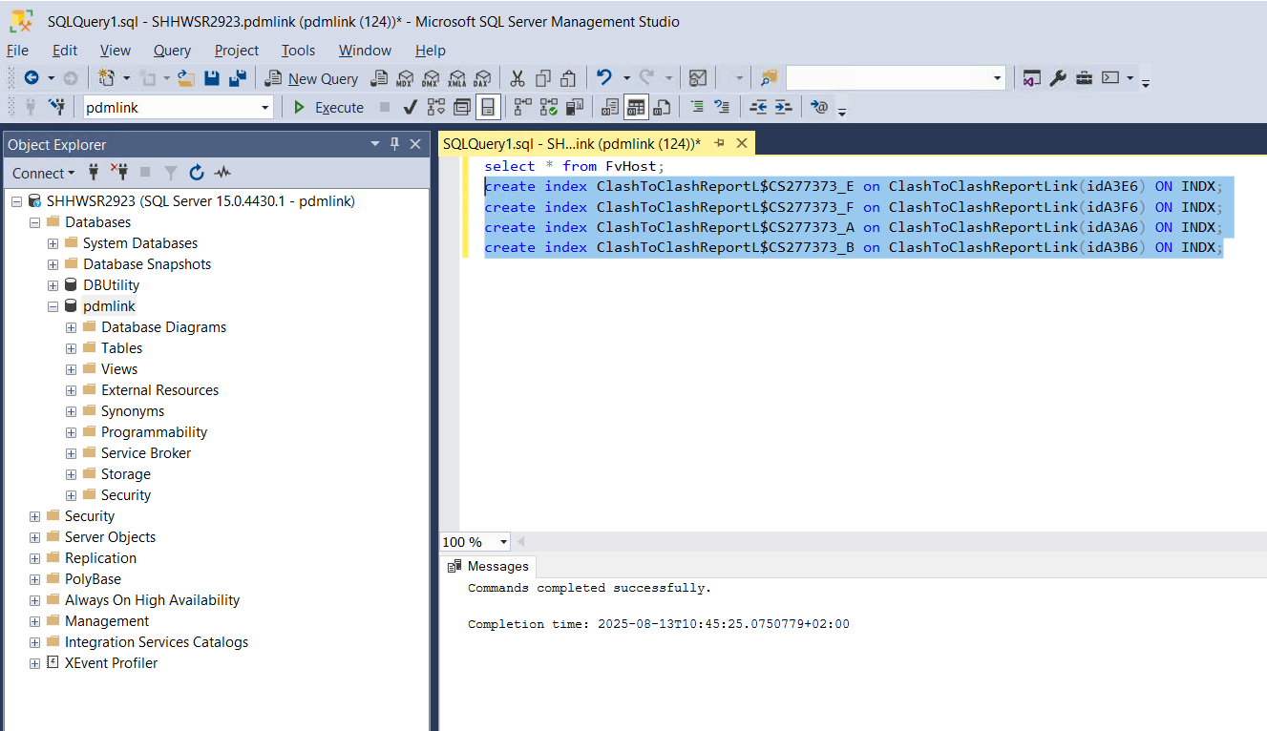

References

PTC Articles
- https://www.ptc.com/en/support/article/CS277373

PTC Cases
- <Case Number>

